United States Congressman
Jodey C. Arrington
19th District of Texas

SERVICE ACADEMY APPLICATION PACKET

UNITED STATES AIR FORCE ACADEMY
UNITED STATES NAVAL ACADEMY
UNITED STATES MILITARY ACADEMY
UNITED STATES MERCHANT MARINE ACADEMY

Congressman Jodey C. Arrington
500 Chestnut St, Suite #819
Abilene, Texas 79602
(325) 675-9779

TX-19 Application for Consideration as a Nominee to the United States
Military, Naval, Air Force, or Merchant Marine Academy

Full Name: ___________________________________________________________________
(first) (middle) (last)

Permanent/Mailing Address (including city, state, and zip code). Include both if they are different:

_____________________________________________________________________________________________

_____________________________________________________________________________________________

E-mail Address: ______________________________________ Birth Date: _____/_____/__________
Primary Phone #: (____) _____-________ Secondary Phone #: (____) _____-_______

Are you a citizen of the United States? ___ Yes ___ No NOTE: You must be a citizen at the time of entrance to an academy.

Name(s) of your parent(s)/guardian(s): ____________________________________________________
Do you and/or your parents reside in the 19th Congressional District of Texas? ___ Yes ___ No
NOTE: For USMA/USNA/USAFA you must be a bona fide resident of the 19th district to receive a nomination from Rep. Arrington. For USMMA you must be a bona fide resident of Texas to receive a nomination from Rep. Arrington.

Name of High School: ___________________________________________ Graduation Year: ______
Name and Phone # of Guidance Counselor: _____________________________ (____) _____-______
GPA: ________ Class Rank: _________ SAT Score: ________ ACT Score: ________

Please rank your Academy preference and indicate if you have opened a file with each Academy:
Academy | Rank | Open File
U.S. Air Force | 1st 2nd 3rd 4th NA | Yes No
U.S. Merchant Marine | 1st 2nd 3rd 4th NA | Yes No
U.S. Military | 1st 2nd 3rd 4th NA | Yes No
U.S. Naval | 1st 2nd 3rd 4th NA | Yes No

TX-19 Application for Consideration as a Nominee to the United States
Military, Naval, Air Force, or Merchant Marine Academy

Full Name: ___________________________________________________________________
(first) (middle) (last)

Athletic Activities – school/travel/community groups:
For grade, please circle the appropriate year[s].) If you plan to participate in an activity your senior year, but
have not started that activity (winter/spring sport), please circle year 12, and place a P next to the year.

Sport JV/V Captain Awards / Honors Grade
___________/_____________/_________/_______________________________/ 9 10 11 12
___________/_____________/_________/_______________________________/ 9 10 11 12
___________/_____________/_________/_______________________________/ 9 10 11 12
___________/_____________/_________/_______________________________/ 9 10 11 12

Extracurricular Activities:
Please check all that apply and circle the number(s) that correspond to the year(s) of the activity(ies). You may
expand on a separate page especially if your activity(ies) is/are not listed here. If you plan to participate in an activity your senior year but have not started that activity (winter/spring), please circle year 12 and place a P next to the year.
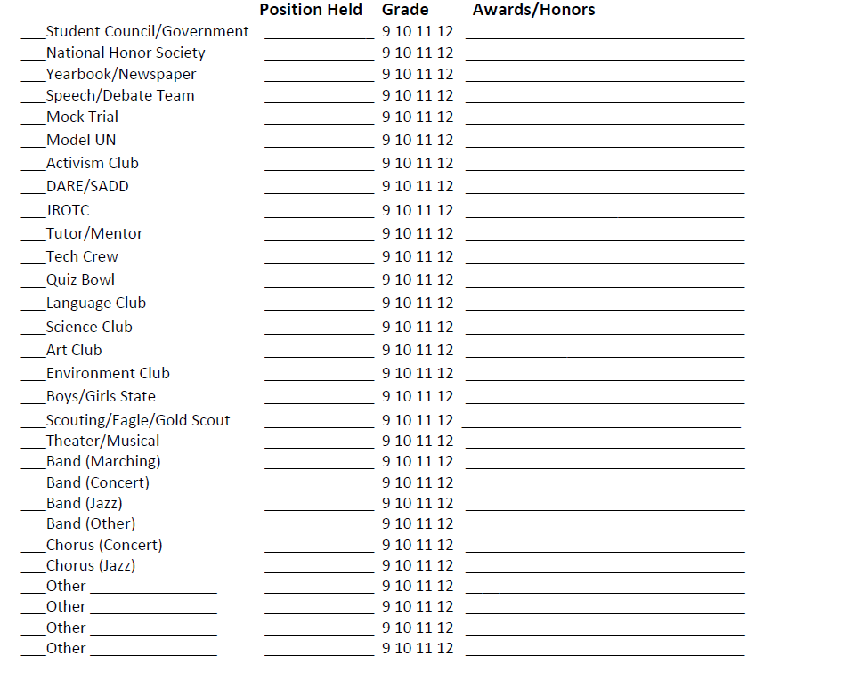
TX-19 Application for Consideration as a Nominee to the United States
Military, Naval, Air Force, or Merchant Marine Academy

Full Name: ___________________________________________________________________
(first) (middle) (last)

Please list any cultural experiences or travel that you have undertaken that demonstrate your leadership skills (include dates of travel). You may expand on this on a separate sheet of paper and attach:
_____________________________________________________________________________________
_____________________________________________________________________________________
_____________________________________________________________________________________ _____________________________________________________________________________________

Community / Volunteer / Spiritual Activities
Please check all that apply and circle the number(s) that correspond to the year(s) of the activity(ies). You may
expand on a separate page especially if your activity(ies) is/are not listed here. If you plan to participate in an activity your senior year but have not started that activity (winter/spring), please circle year 12 and place a P next to the year.
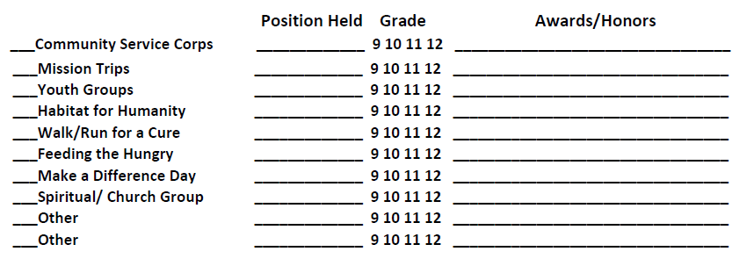
Outside Awards / Honors
Please list any awards/honors not listed above. For example: National Merit Scholar, leadership, Writing/Essay awards, DAR Awards, Spirit Awards, HOBY, Governor’s School:

Award / Honor Grade
____________________________________________________________________________ 9 10 11 12
____________________________________________________________________________ 9 10 11 12 ____________________________________________________________________________ 9 10 11 12

Employment History
Have you held a job(s) during the school year/in the summer? ____ Yes ____No
Please describe your job(s) and dates of employment. Remember, if you are being paid, it is a job.
__________________________________________________________________________________
__________________________________________________________________________________
__________________________________________________________________________________

TX-19 Application for Consideration as a Nominee to the United States
Military, Naval, Air Force, or Merchant Marine Academy

Full Name: ___________________________________________________________________
(first) (middle) (last)

Candidate Fitness Assessment
Push-ups: _________________________ Mile Run: ____ minutes ______seconds
Shuttle Run: _________________seconds Basketball Throw: ______________ft.
Pull-ups: __________________________ Sit Ups _________________________
Criminal Information
I have been convicted of a felony/misdemeanor Yes No
I have been the target of a criminal investigation Yes No
I have been investigated by children/youth services for allegations of abuse Yes No
I have been charged with a crime Yes No
(If you answered yes to any of the above, please explain and attach to the application.)

General Information

Are you applying to other nominating sources? You are allowed to, and in fact are encouraged to, apply for at least four nominations. (your own Member, your two Senators, and the Vice President). Please check all that apply:

____Senator Cornyn ____Senator Cruz ____Vice President ____Service Related

Are you applying for an ROTC scholarship? Again, you are encouraged to do so as it shows commitment to becoming an officer: YES______ NO ______ If yes, to which schools? _____________________________________________________________________________________

Academy Application Timeline -- For your TOP choice, please note the date you sent each (or completed interview) to that Academy. NOTE: May be worded slightly differently by each academy.

SAT/ACT Scores _____/_____/__________
Transcript _____/_____/__________
Candidate Statement/Essay _____/_____/________
Activities/Personal Data Record _____/_____/__________
Interview with FF/BGO/Liaison Officer _____/_____/__________ CFA Scores _____/_____/__________
Letters of Recommendation/School Officer Evaluation - list date FINAL one was sent _____/_____/__________

TX-19 Application for Consideration as a Nominee to the United States
Military, Naval, Air Force, or Merchant Marine Academy

Full Name: ___________________________________________________________________
(first) (middle) (last)

Medical Information: Have you taken/been scheduled to take your Academy medical exam (scheduled by DoDMERB)? YES______ NO ______ If yes, when? _____/_____/_________

As part of your application for admission to an Academy, you will be required to take a medical exam through DoDMERB (the Department of Defense Medical Examination Review Board). The following are common conditions that may cause an Academy to require you to obtain a waiver for admission.

NOTE: Receiving a medically disqualified notice from DoDMERB is NOT the end of the process.
Many times, academies do grant waivers so be sure to work through the process completely.
Timely submission of all documentation to DoDMERB/Academy(ies) is key to a positive outcome.

•Wearing corrective eye wear, especially if not correctable to 20/20.
•Laser surgery of any type.
•Diagnosis of color blindness.
•Diagnosis of asthma, hay fever, or allergies, especially after the age of 12.
•Diagnosis of ADD/ADHD/Learning disabilities, especially if you have used medication since the end of your sophomore year.
•Surgery or broken bones in the last ten years.
•Tattoos: especially if visible in any uniform and/or they can be deemed offensive.
•Diagnosis of concussion(s), especially multiple ones.
•Diagnosis of eczema.

Personal Questionnaire: On a separate piece(s) of paper, write no more than one paragraph on EACH of the following questions:

- In what ways have you prepared yourself for study at a service academy?
- When did you decide you wanted to attend an academy and how was that interest generated?
- Why do you want to attend a service academy rather than a traditional civilian university?
- USAFA and USMA each have an honor code and USNA and USMMA each have an honor concept. Explain how you intend to uphold honor at an academy and why it is important not only while at an academy but throughout your military career.
- What makes you stand out among the other candidates? Please include any experience of statements that show you will make a good officer in the United States Military.
- What disappointments/obstacles have you encountered in life? How did you handle these situations?
- Based on what you read in the news and see in your local community, what do you see as the biggest challenge you and your peers will face as you join the military?

TX-19 Application for Consideration as a Nominee to the United States
Military, Naval, Air Force, or Merchant Marine Academy

Full Name: ___________________________________________________________________
(first) (middle) (last)

Once you have completely filled out this file, please sign and date below. When you sign and date below you are attesting that the above information is correct, your own work, and that you are fully aware of and intend to meet to the best of your abilities the service commitment required of an academy graduate.

It is my sincere desire to attend a U.S. Service Academy, and I fully intend to vigorously pursue an academic course of study if appointed. I understand that attending a service academy also requires a minimum of five years military service following graduation. I am a U.S. Citizen or will be by July 1, 2024, and I will be at least 17 years old, but not yet 23 years old on July 1, 2024, I am not married; I am not pregnant; I have no child support obligation; I am a legal resident of the 19th Congressional District of Texas.

Signature: ________________________________ Date: _____/_____/__________

Congressman Jodey C. Arrington
2023-2024 Application for Nomination to a U.S. Service Academy

CHECK LIST

Send the items below to my Abilene Office by October 31, 2023. All items must
be received by the deadline to consider an application complete. If you would like verification of delivery, please request a return receipt from the US Post Office or other mail vendor.
- Application form must be completed and signed by applicant. Must be legible or typed. Please read this application carefully and double check. Before mailing, be sure to compare your application to the check list provided.

- Personal Questionnaire should be completed and thoroughly answered. This questionnaire, along with the information provided on the application, is your best opportunity to illustrate your strengths and character.

- Personal Recommendation Forms (3) completed by counselors, principals, teachers, coaches, or religious leaders (i.e. priests, rabbis, and ministers). You are required to return three (3) Personal Recommendation Forms but no more than three. Recommendation forms are attached in this packet.

- Official copy of your high school transcript including courses currently in progress, GPA through junior year, and class rank. If you would like to provide your transcript from your senior year, you may send it as an update as long as your application is complete by October 31, 2023.

- Official copy of your college transcript (if applicable) including courses currently in progress.

- Current photograph (wallet size) with your name and hometown written on the back.

- Copy of your official SAT or ACT scores/report, if they are not sent directly from the college boards. NOTE: Test scores must be received by October 31, 2023. Carefully consider the dates that you are taking the tests; if you wait until September or October, your scores may not arrive on time. My test codes are: SAT: 6079 ACT: 7700
Deadline for receiving application – documents is October 31, 2023.

Plan for mail delays and send your documents in EARLY to:

Congressman Jodey C. Arrington
Attn: Military Academy Nominations
500 Chestnut St, Suite #819
Abilene, Texas 79602

2023 - 2024 Application for Nomination to a U.S. Service Academy

PERSONAL RECOMMENDATION FORM
To be completed by a teacher, school counselor/principal, religious leader, community leader or employer.

Note to applicant: You must turn in three personal recommendation forms by October 31, 2023, or your application will not be considered complete. Additional letters are welcome.

Name of Applicant (Last/First/Middle) _ ____________________________________________________
To the recommender: The person above is applying for nomination to a United States Service Academy. The academies provide a college education and training for students to become commissioned officers in the Armed Forces following graduation. The questions below are designed to provide the information necessary to select the best qualified candidates. By law, all admissions materials must be shown to a student upon request. Each student must submit three personal evaluation forms along with a complete application packet by October 31, 2023. Failure to return this form to the student by that date will jeopardize the student’s application. PLEASE ANSWER THE SPECIFIC QUESTIONS ASKED ON THIS FORM. Use additional pages if necessary. You are welcome to submit a separate letter of recommendation, but that letter will not help the applicant complete his/her file unless it is accompanied by this form.

- How long have you known this applicant and in what capacity?

- Describe the applicant’s talents, strengths, and leadership ability.

- How could the applicant improve to rise to the challenges presented by a U.S. service academy?

- Do you believe the applicant plans to pursue military service as a career? Does he/she truly understand the commitments and obligation that accompany a service academy education?

- How does the applicant handle stressful/challenging situations? Has the applicant encountered failure and how did he/she manage the situation?

- Do you know of any personal circumstances that might affect the applicant’s performance at the academy?

- Please select the statement that best applies to this applicant:

______ THE BEST, students like this appear once in several years _______ EXCELLENT

______ ABOVE AVERAGE _______ FAIR

To the recommender: Please give this completed form, along with any additional pages or letters, sealed in an envelope and signed across the flag, to the applicant for inclusion in the application packet. Thank you.

Name (signature) _________________________________________________ Date _____/_____/_____

Name (printed) ___________________________________________________ Title ______ ___

Address _________________________________________________________________________________________
Work or Home Street/P.O. Box City Zip Phone

